Name : Khush Pithva 24BCE174
Subject : Data Structure (2CS501)
Practical no.: 2A
Practical No.: 8(A)
AIM: Create a hash table data structure and add 20 elements. Use separate chaining to handle collisions.

Methodology followed:
#include<stdio.h>
#include<stdlib.h>

typedef struct Node{
int data;
struct Node* next;
} Node;

Node* hashtable[10];

int hashfnc(int key){
return key % 10;
}

Node* createNode(int key){
Node* newNode = (Node*)malloc(sizeof(Node));
newNode->data = key;
newNode->next = NULL;
return newNode;
}

void insert(int d){
int idx = hashfnc(d);
Node* newNode = createNode(d);

if(hashtable[idx] == NULL){
hashtable[idx] = newNode;
}
else{
Node* temp = hashtable[idx];

while(temp->next != NULL){
temp = temp->next;
}
temp->next = newNode;
}
}

void display(){
for(int i=0; i<10; i++){
printf("Index %d : ", i);
Node* temp = hashtable[i];
if(temp == NULL){
printf("NULL");
}
else{
while(temp != NULL){
printf("%d -> ", temp->data);
temp = temp->next;
}
printf("NULL");
}
printf("\n");
}
}

int main() {
for (int i = 0; i < 10; i++) {
hashtable[i] = NULL;
}

int sz;
printf("Enter number of elements to insert: ");
scanf("%d", &sz);

int elements[sz];

printf("Enter %d elements:\n", sz);
for (int i = 0; i < sz; i++) {
printf("Element %d: ", i + 1);
scanf("%d", &elements[i]);
insert(elements[i]);
}

printf("\nHash Table\n");
display();

return 0;
}

Output:
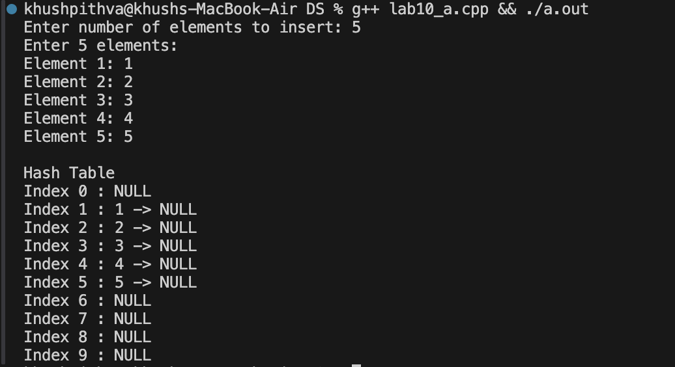

Practical No.: 8(B)
AIM: Write a program to implement heap sort algorithm for sorting a given set of integers in ascending order.

Methodology followed:
#include <iostream>
#include <vector>
using namespace std;

int main() {
int n;
cout << "Enter number of elements: ";
cin >> n;

// Input validation
if (n <= 0) {
cout << "Invalid size." << endl;
return 0;
}

vector<int> a(n);
cout << "Enter " << n << " elements: ";
for (int i = 0; i < n; i++) {
cin >> a[i];
}

int target;
cout << "Enter the target element: ";
cin >> target;

bool found = false;
for (int i = 0; i < n; i++) {
if (a[i] == target) {
cout << "Element found at position: " << i + 1 << endl;
found = true;
break;
}
}

if (!found) {
cout << "Element not found in the array." << endl;
}

return 0;
}
Output:
